ENGINEERING HANDOVER

Reiri DB Backup Tool
  - Code Flow and Engineering Handover
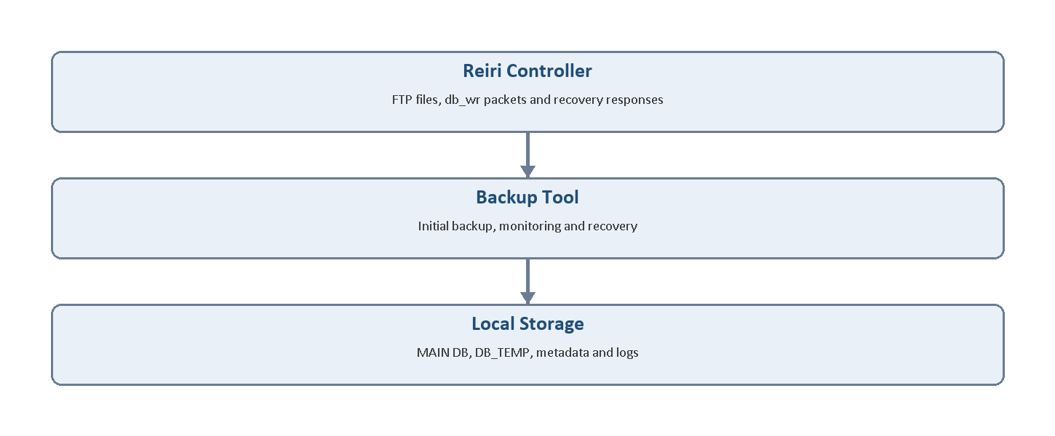
System boundary: controller data enters the backup tool and is persisted locally.

Document field | Value
Document owner | Kong Jeng Yang
Receiving engineer | Jared Ong
Department | UP Control Development
Version | 1.0.0
Handover date | 7 August 2026
Confidentiality | Internal Use

Contents
- System purpose and boundaries
- Repository and source-code map
- Application startup
- Navigation and login
- Initial backup gate
- FTP initial backup
- Local initial backup
- Initial backup completion and storage
- Refactored Home architecture
- Home initialization sequence
- Connection monitoring
- Continuous real-time backup
- Database status and backup logging
- Metadata and gap detection
- Recovery classes
- Recovery execution
- Database merge safeguards
- Runtime scenarios
- Validation preparation
- DB Compare Tool procedure
- Configuration, security and localization
- Troubleshooting
- Known risks and recommended reading order

OVERVIEW

1. System purpose and boundaries
The Reiri DB Backup Tool is a Flutter desktop application, primarily intended for Windows. It maintains a local copy of operational and time-series databases from a Reiri controller.

The application performs three main operations:
- Create an initial database baseline by FTP download or local import.
- Receive new controller database records continuously.
- Detect and recover records missed during disconnection, Windows sleep, application closure or temporary controller unavailability.

Managed databases
File | Purpose | Frequency
history.db | Controller event history | Event-based
meter.db | Meter totals and interval consumption | 15 minutes
optime.db | Operating-time values | 15 minutes
trend.db | Trend values | 5 minutes
ppd.db | PPD calculation data | 15 minutes

Scope: The current backup tool manages these five SQLite databases. Other setup-tool files are outside the continuous backup and recovery flow.

ARCHITECTURE

2. Repository and source-code map
Folder or file | Responsibility
lib/main.dart | Application startup, window handling, theme, localization and Splash
lib/screen/ | Full application screens
lib/view/ | Dashboard, settings, recovery, logs, FTP and local-import views
lib/service/ | Monitoring, database status, recovery and logging services
lib/provider/ | Riverpod state for recovery and backup logs
lib/model/ | Database, metadata and log models
lib/lib/ | Constants, time rules, DB probing and utilities
lib/widget/ | Small reusable widgets
../reiri_app_core | Controller commands and actual real-time SQLite writes
../std_widget | Shared visual widgets

Important source split: This repository controls the backup workflow. The sibling reiri_app_core package performs controller communication and writes incoming records into SQLite.
Shared-core file | Responsibility
command_db.dart | Creates real-time and recovery controller commands
reiri_controller.dart | Receives controller packets
reiri_db.dart | Routes and writes records into the five databases

CODE FLOW

3. Application startup
main()
-> WidgetsFlutterBinding.ensureInitialized()
-> Initialize Windows window behaviour
-> Install Flutter and async error handlers
-> Install MyHttpOverrides
-> ProviderScope
-> App

App responsibilities
- Initialize the shared app object.
- Configure themes and supported locales.
- Initialize the Windows tray service.
- Handle close-button and tray-exit behaviour.
- Keep unattended backup running when the window is hidden.
- Open SplashScreen.

Error handling
Unhandled Flutter, platform and asynchronous errors are written to the active backup log when the log location is already known.
SSL behaviour: MyHttpOverrides accepts controller self-signed certificates. This is intentional for controller communication but must be treated as a security exception.

CODE FLOW

4. Navigation and login flow
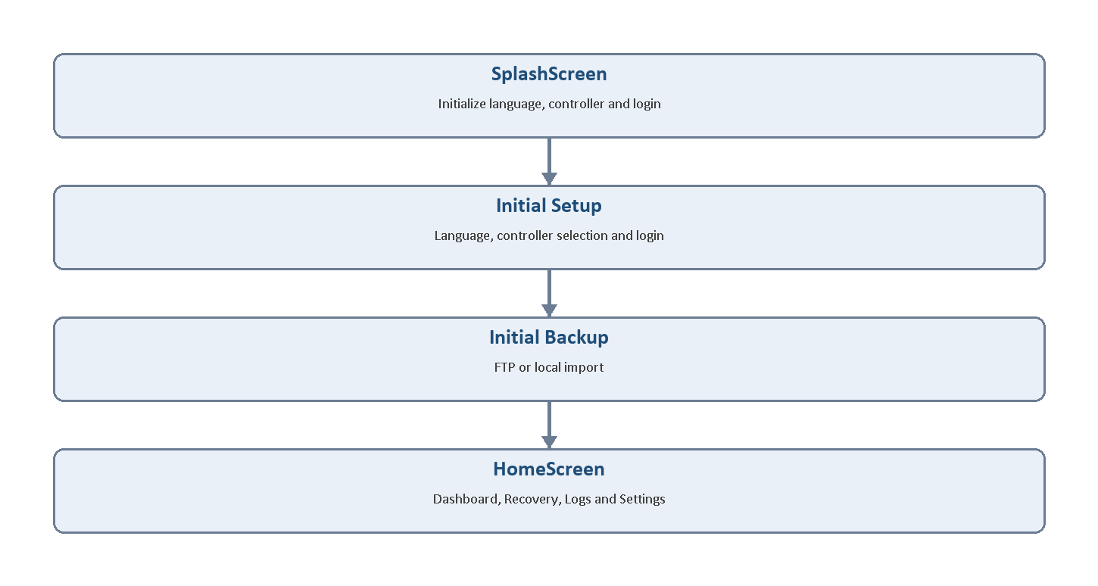
Startup navigation from SplashScreen to the operational HomeScreen.

Navigation rules
Condition | Destination or action
No language | LanguageSelectionScreen
No registered controller | ControllerSelectionScreen
Controller available; auto-login disabled | LoginScreen
Auto-login enabled | app.login()
Connection ready | Check InitialBackupScreen.needsInitialBackup()
Initial backup missing or invalid | InitialBackupScreen
Initial backup valid | HomeScreen

LoginScreen.tryLogin() creates the controller, requests login, waits for the ready state, validates the initial backup and opens the correct next screen.

INITIAL BACKUP

5. Initial backup gate

Gatekeeper method
InitialBackupScreen.needsInitialBackup(macaddr)

Checks performed
- The controller MAC address must exist.
- INITIAL_HISTORY_BACKUP_DONE_V1 must contain done = true.
- A stored backup root must exist.
- The controller folder must be derived from the MAC address.
- Every managed database must exist.
- Every managed database must have a non-zero file size.

Expected folder
<root>\<safe-MAC>\DB\

MAC conversion
02:81:0c:0c:f4:2f -> 02_81_0c_0c_f4_2f
Result: If any validation fails, the operator is returned to InitialBackupScreen.

INITIAL BACKUP

6. FTP initial backup flow

User flow
- Select FTP as the backup method.
- Select the backup root.
- Start the download.
- Wait until all five files have been processed.
- Allow the application to complete setup and open Home.

Code flow
InitialBackupFtpView._pickBackupPath()
-> _startDownload()
-> Create <root>\<MAC>\DB
-> FTPConnect.connect()
-> setTransferType(binary)
-> changeDirectory('/var/www/db')
-> download five DB files
-> probeSourceFolder()
-> probeResultsToGaps()
-> onCompleted('ftp', root, initialGaps)
Important behaviour: A missing remote file is skipped during the transfer loop, but the final initial-backup gate requires all five files. The downloaded files are probed after transfer because a controller write boundary may occur while FTP is running.

INITIAL BACKUP

7. Local initial backup flow

User flow
- Select Local Import.
- Select the source DB folder.
- Wait for the five-file scan.
- Select the backup root.
- Start the import and wait for completion.

Code flow
_pickSourcePath()
-> _scanFolder()
-> probeSourceFolder()
_pickBackupPath()
_startImport()
-> source folder -> <root>\<MAC>\DB
-> staging DB -> application working directory
-> probeSourceFolder() again
-> probeResultsToGaps()
-> onCompleted('local', root, initialGaps)

Import conditions
- Scanning has finished.
- Source and destination paths are selected.
- Every required file exists.
- No import is already running.
Destination handling: The user-selected staging DB folder is cleared before copying. The application working directory is not cleared; the five files are overwritten individually.

INITIAL BACKUP

8. Initial backup completion and storage

InitialBackupScreen.onCompleted() actions
- Mark initial backup as completed and store the backup root.
- Initialize BackupMetadataService and reset previous recovery metadata.
- Delete a stale DB_TEMP directory.
- Save gaps discovered during source probing.
- When gaps exist, set realtimeTemp, pending and autoFill = true.
- When no gap is known, save completion time as a disconnect boundary.
- Clear previous structured backup-log entries.
- Remove previous routes and open HomeScreen.

Storage layout
<root>\
└── <safe-MAC>\
├── DB\
├── DB_TEMP\
├── backup_metadata.json
└── backup log\
TEMP directory: DB_TEMP exists only when recovery staging is required.

HOME AND SERVICES

9. Home architecture
Earlier code placed most backup orchestration in HomeScreen. The current implementation separates the main responsibilities.
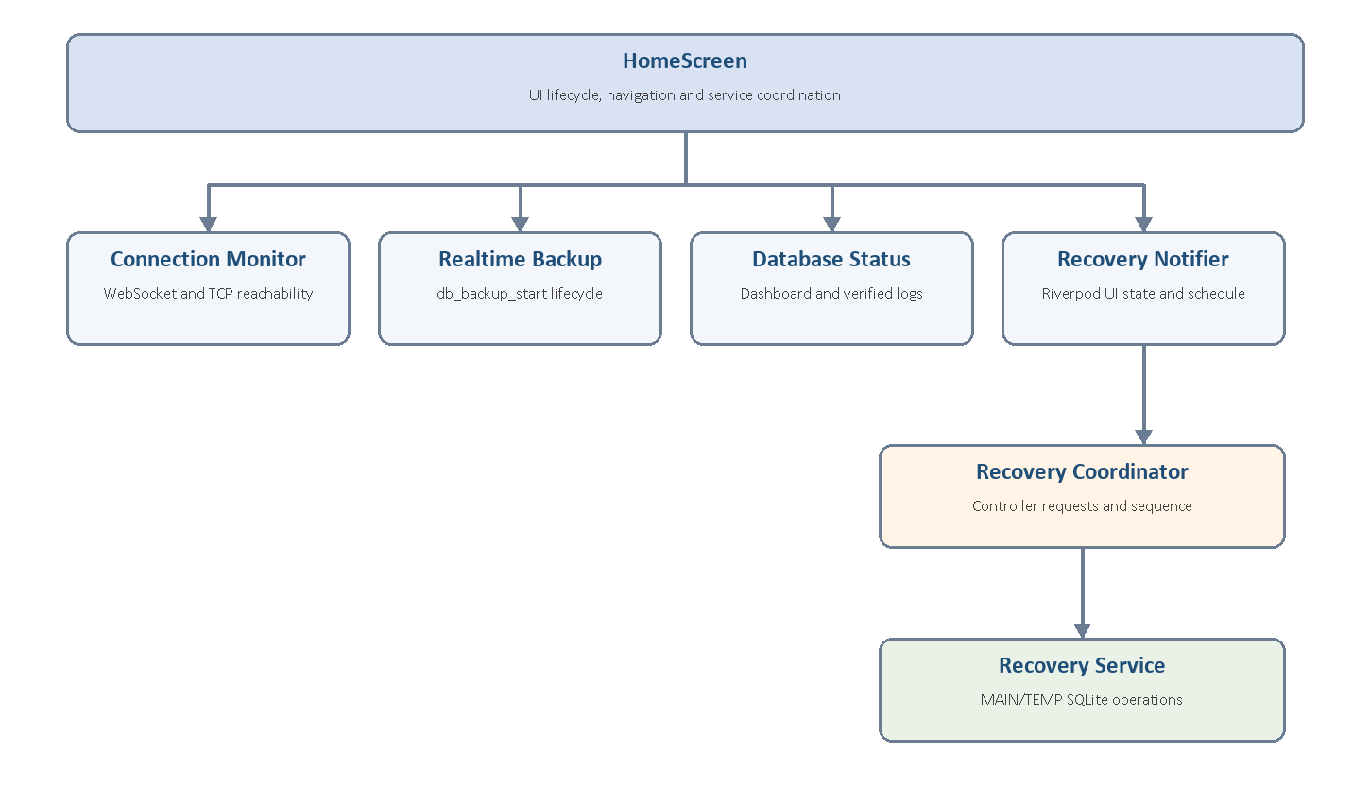
Current service split after the Home-page refactor.
Class | Primary responsibility
HomeScreen | UI lifecycle, navigation and service coordination
ConnectionMonitorService | Controller-ready state and TCP reachability
RealtimeBackupService | Real-time subscription lifecycle
DatabaseStatusService | Dashboard status and verified logs
RecoveryNotifier | Riverpod recovery UI state and scheduling
RecoveryCoordinator | Controller recovery requests and sequence
RecoveryService | MAIN/TEMP routing and SQLite operations
BackupMetadataService | Persistent heartbeat, gap and flush state

HOME AND SERVICES

10. Home initialization sequence
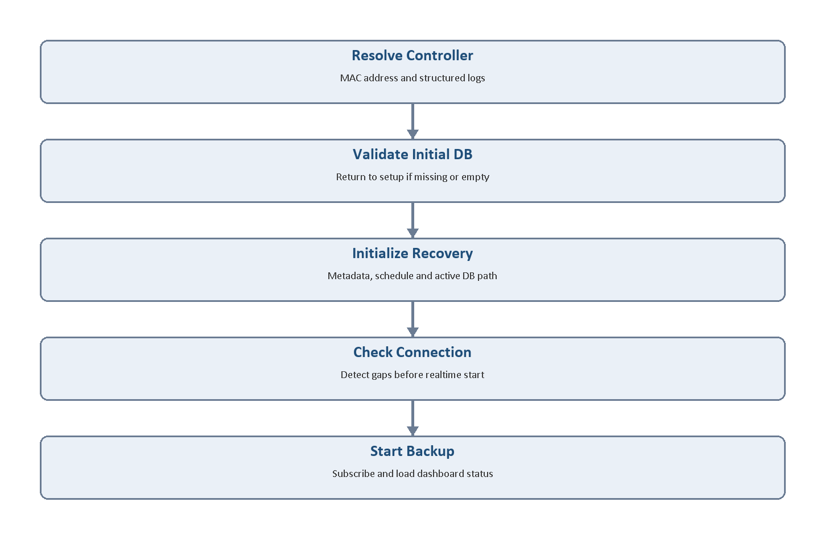
Home initialization validates storage and recovery state before real-time backup starts.

HomeScreen.initState()
- Create ConnectionMonitorService.
- Create RealtimeBackupService.
- Create DatabaseStatusService.
- Call _init().
- Start the one-minute refresh timer.
- Start the ten-second network timer.

_init() order
- Resolve MAC and initialize structured logs.
- Revalidate the initial backup.
- Load the root and initialize the daily log.
- Initialize recovery metadata and schedule.
- Open the active MAIN or TEMP database.
- Check network, detect gaps and then start real-time backup.
- Load dashboard database status.

RUNTIME

11. Connection monitoring
Effective connection: The controller connection must be ready and the network must be reachable.

TCP probe
- The local controller address is read from selected-controller data.
- Port 52001 is tested with a two-second timeout.
- Cloud controllers bypass the local TCP check.
- Three consecutive failures are required before declaring network loss.

Connection-state actions
State | Actions
Connected | Log reconnection; detect gaps; start real-time backup; update tray state
Disconnected | Reset real-time service; mark inactive; record disconnect; update tray state

Windows sleep detection
The one-minute refresh timer compares the current tick with the previous tick. A delay greater than two minutes is treated as a possible sleep interval. The previous tick becomes the disconnect boundary, followed by a new network check.

RUNTIME

12. Continuous real-time backup

Start flow
HomeScreen._tryStartRealtimeBackup()
-> RealtimeBackupService.tryStart()
-> RealtimeDbBackup.start()
-> app.requestController(command)
-> command = 'db_backup_start'

Record flow in reiri_app_core
Controller sends db_wr
-> ReiriController receives packet
-> app.db.save(packet data)
-> ReiriDb routes by database type
Type | Writer
optime | addOptimeData()
meter | addRealtimeMeterData()
trend | addTrendData()
ppd | addRealtimePpdData()
history | addHistoryData()

Routing: The current app.db path determines whether incoming records are written to MAIN DB or DB_TEMP.

RUNTIME

13. Database status and backup logging
DatabaseStatusService.load() builds dashboard status for each managed database.

Checks performed
- Locate the MAIN database file.
- Include the TEMP file when recovery is active.
- Read the latest modification time.
- Read and verify the latest database record.
- For history, inspect row progress when the latest date is unchanged.
- Check recovery metadata for a database gap.
- Return status and last real-time event to HomeScreen.

Possible states
State | Meaning
synced | No active gap is recorded
delayed | Latest record has not advanced as expected
notFound | The database file is unavailable
missingDisconnected | Gap exists while controller is unavailable
missingScheduled | Gap exists and recovery is scheduled

Success rule: A file timestamp change alone is not enough. A successful real-time backup log is created only after actual record advancement is verified.

RECOVERY

14. Metadata and gap detection

Metadata file
<root>\<safe-MAC>\backup_metadata.json
Field | Purpose
disconnectedAt | Earliest known start of the current outage
lastHealthyAt | Latest healthy real-time checkpoint
tConnect | Most recent connection time
detectedGaps | Merged recovery range by database
gapPeriods | Individual periods retained for processing and display
backupState | realtimeMain or realtimeTemp
tempDbPath | Active recovery staging directory
flushStatus | none, pending, inProgress or completed
autoFill | Run first recovery immediately

Gap rules
- Trend checks missed 5-minute boundaries.
- Meter, optime and PPD check missed 15-minute boundaries.
- Any positive disconnection may contain missing history events.
- Existing and new gaps are merged by database.

RECOVERY

15. Recovery classes
Class | Detailed responsibility
RecoveryNotifier | Exposes Riverpod state, progress, schedule and UI messages
RecoveryCoordinator | Fetches controller data and sequences TEMP-to-MAIN writes
RecoveryService | Opens, stages, copies, deduplicates and cleans databases
BackupDbAccess | Creates and parses controller *_db_backup requests
BackupMetadataService | Stores crash-safe recovery checkpoints
RecoveryView | Displays gaps, schedule and flush progress

Separation of responsibilities
RecoveryNotifier = user-interface state
RecoveryCoordinator = recovery process control
RecoveryService = SQLite files and paths
RECOVERY

16. Exact recovery execution
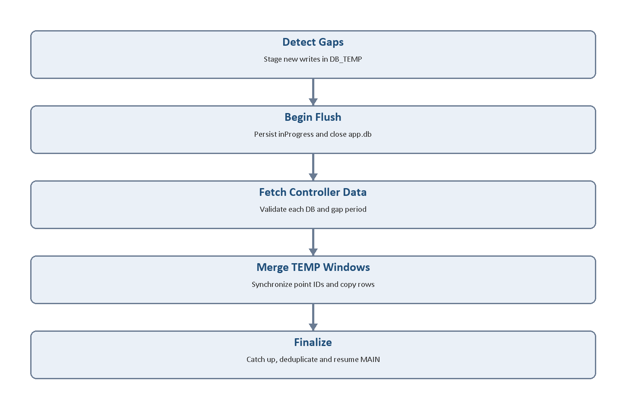
Interleaved recovery keeps controller gap-fill and TEMP writes in chronological order.

RecoveryNotifier.runFlushNow()
- Confirm a recovery service is attached.
- Confirm active gaps exist and another flush is not running.
- Set isFlushing and call RecoveryCoordinator.runInterleavedFlush().

Coordinator sequence
- Persist inProgress and close app.db handles.
- Group and sort gap periods by database.
- Fetch, validate and write controller records into MAIN.
- Flush matching TEMP windows into MAIN.
- Finalize, catch up, deduplicate and refresh the meter cache.
- Return recovery log entries and resume MAIN real-time writes.
Timeout: Each controller recovery response has a 120-second timeout.

RECOVERY

17. Database merge safeguards

MAIN/TEMP protection
- New real-time records are routed to TEMP before gap calculation.
- A new TEMP database receives MAIN point_id mappings.
- The meter value cache is seeded from the latest MAIN values.
- New points created during recovery are synchronized before copying rows.

Interval database merge
- Resolve the TEMP point's string identifier.
- Resolve or create the correct MAIN db_id.
- Copy rows using the MAIN identifier.
- Respect the existing date + id uniqueness rule.

History merge
history.db uses its text identifier and normalized JSON data. It does not use the same surrogate point-ID conversion.
Failure behaviour: Reopen active handles, keep DB_TEMP, keep gap metadata and schedule another attempt.

OPERATIONS

18. Runtime scenario matrix
Scenario | Expected behaviour
First run | Language, controller and login setup, followed by initial backup
Valid restart | Open stored path, load metadata, check connection and resume backup
Missing initial file | Return to Initial Backup
Short network loss | Record the disconnect; recover immediately when every pending gap is under one minute; history recovery may be required
Interval boundary missed | Add gaps for affected interval databases
Windows sleep | Detect timer delay, record gap start, reconnect and recover
Instant recovery enabled | Start recovery immediately after detection
Scheduled recovery | Keep writing to TEMP until configured time
Application closed | Record disconnect boundary before shutdown
Recovery interrupted | Change inProgress to pending on restart
Controller timeout | Keep TEMP and gap metadata; retry later
Backup path changed | Optionally migrate controller data to new root
Logout | Record disconnect, stop active state and return to login

VALIDATION

19. Validation preparation using Setup Tool
Use Reiri Setup Tool to download an independent controller snapshot. This becomes the source reference for validating backup-tool output.

Evidence structure
Validation_<date-time>\
├── 01_SetupTool_Source\DB\
├── 02_BackupTool_Output\<safe-MAC>\DB\
└── 03_Comparison_Evidence\

Setup Tool procedure
- Connect the PC and controller to the same network.
- Open Reiri Setup Tool; register or select the controller; log in.
- Open Backup Tab, select an empty destination and start Database Backup.
- Confirm the replacement warning and wait for completion.
- Copy the resulting DB folder into 01_SetupTool_Source.
- Do not edit the source files.
Comparison scope: The Setup Tool downloads ten files. Compare only history.db, meter.db, optime.db, trend.db and ppd.db with this project.

VALIDATION

20. DB Compare Tool procedure
- Close any SQLite viewer that has the databases open.
- Open DB Compare Tool.
- Choose 01_SetupTool_Source\DB as Source.
- Choose 02_BackupTool_Output\<safe-MAC>\DB as Target.
- Select the same database file and table on both sides.
- Select Map Columns and confirm matching column names.
- Select date and id for Key columns and the rest as Compare columns.
- Select Compare.
- Review Total, Match, Different, Only in Source and Only in Target.
- Use Differences only and Missing only filters.
- Find any differences between 2 DB tables side by side.
- Repeat for every user table in each managed database.
Direction: Source is the Setup Tool DB folder. Target is the Reiri DB Backup Tool DB folder.
Database lock: Close DB Compare Tool before retrying backup or recovery operations that require exclusive access.

OPERATIONS

21. Configuration, security, logging and localization
Setting | Value or location
Backup root | Stored per controller
Default recovery time | 03:00
Instant recovery default | Disabled
MAC folder format | Colons replaced by underscores
MAIN directory | DB
TEMP directory | DB_TEMP
Metadata | <root>\<safe-MAC>\backup_metadata.json
Daily log | <root>\<safe-MAC>\backup log\backup_YYYY-MM-DD.log

Security
- Do not reproduce FTP or controller passwords in this document.
- FTP authentication is currently embedded in code.
- Global certificate validation is disabled for self-signed controllers.
- Review both items before external or production distribution.

Supported locales
English, Spanish, Brazilian Portuguese, Simplified Chinese, Traditional Chinese, Hong Kong Chinese, Vietnamese, Thai, Indonesian and Japanese.

SUPPORT

22. Troubleshooting
Symptom | Check | Corrective action
Dependency not found | Sibling folder paths | Clone required repository beside this project
Controller not found | Network and discovery | Check subnet, controller power and firewall
Login not ready | Connection and credentials | Verify controller reachability and account
FTP backup fails | IP, FTP port, permissions | Retry on same network to an empty folder
Initial backup repeats | Five DB files and root | Restore folder or perform backup again
Realtime inactive | Local DB and controller ready | Review RealtimeBackup log lines
Recovery repeats | Controller response or DB write | Preserve DB_TEMP; reconnect and retry
Recovery timed out | 120-second timeout | Check controller load and network
Wrong meter amount | Point ID or meter cache | Compare point_id and meter rows
Database locked | External DB process | Close DB viewer and Compare Tool
Dashboard static | Latest record progress | Check controller writes and DB tables
Log unavailable | Backup root and MAC | Confirm root and controller selection

HANDOVER

23. Known risks, reading order and sign-off

Known risks
- The reviewed working tree contains recovery and handover changes that must be committed after senior review.
- The package and displayed application version are aligned at 1.0.0.
- Sibling dependency revisions are not pinned.
- FTP authentication is embedded and TLS validation is broadly disabled.
- Automated end-to-end controller tests are limited.
- Backup retention, disk-space controls and the installer process require documentation.

Recommended reading order
- backup_database.dart and initial_backup_constants.dart
- main.dart, login_screen.dart and initial_backup_screen.dart
- initial_backup_ftp_view.dart and initial_backup_local_import_view.dart
- home_screen.dart and the three refactored Home services
- backup_metadata_service.dart and recovery_provider.dart
- recovery_coordinator.dart and recovery_service.dart
- Shared-core command_db.dart, reiri_controller.dart and reiri_db.dart

Sign-off
Item | Owner | Date | Status
Repository access
Build demonstration
Backup demonstration
Recovery demonstration
DB comparison evidence
Receiving engineer acceptance

